Cycling Strategy for Harrow
2015-2018
Appendices
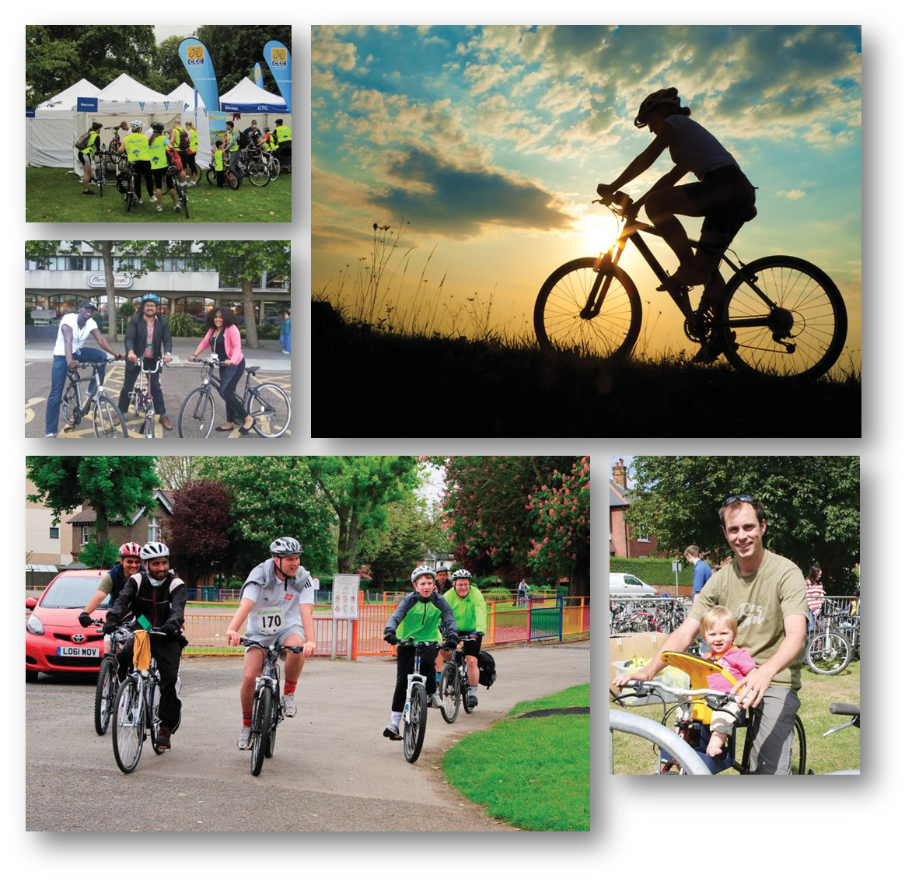

CONTENTS

APPENDIX A Existing Cycling Infrastructure Map
APPENDIX B Existing Cycle Parking Map
APPENDIX C Aspirational Cycling Infrastructure & Cycle Quietways map
APPENDIX D Cycling Policies in the Harrow Sustainable Transport Strategy
APPENDIX E Linking Borough Cycling Targets to Cycling Policy
APPENDIX F Borough Cycle Action Plan
APPENDIX G Borough Cycle Implementation Plan
APPENDIX H Borough Cycling Monitoring Action
APPENDIX A Existing Cycling Infrastructure Map

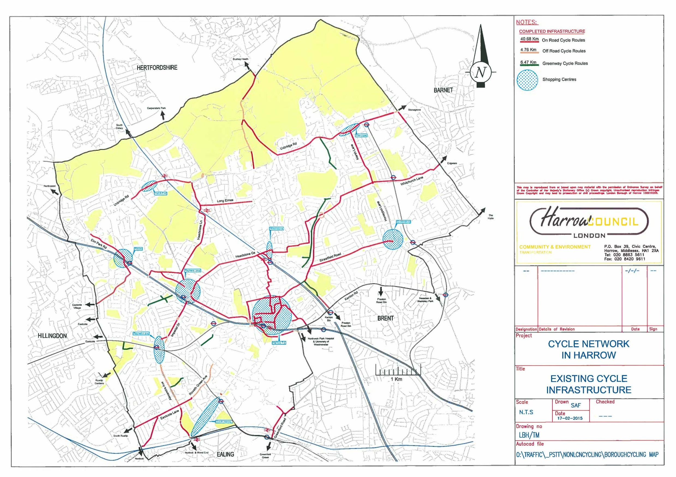

APPENDIX B Existing Cycle Parking Map
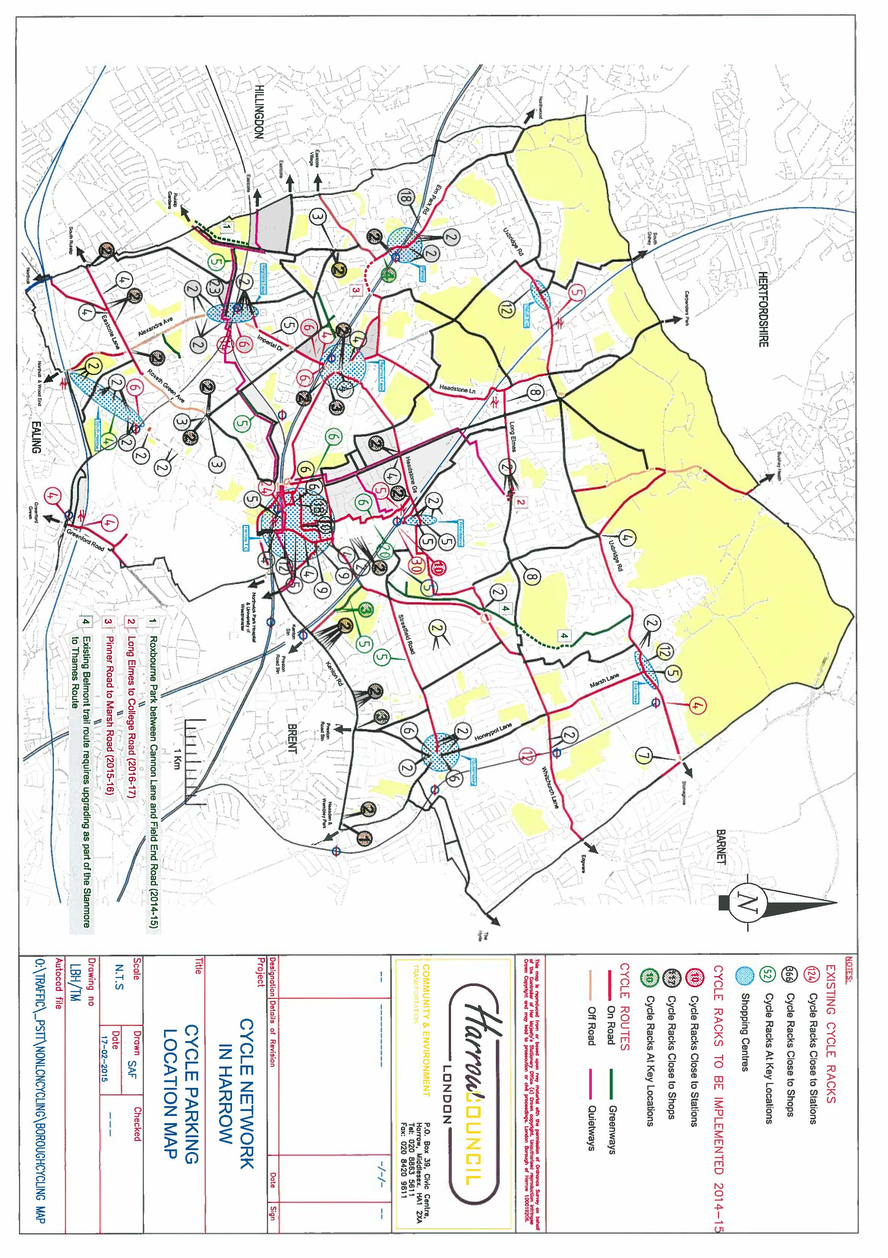
APPENDIX C Aspirational Cycling Infrastructure & Cycle Quietways map
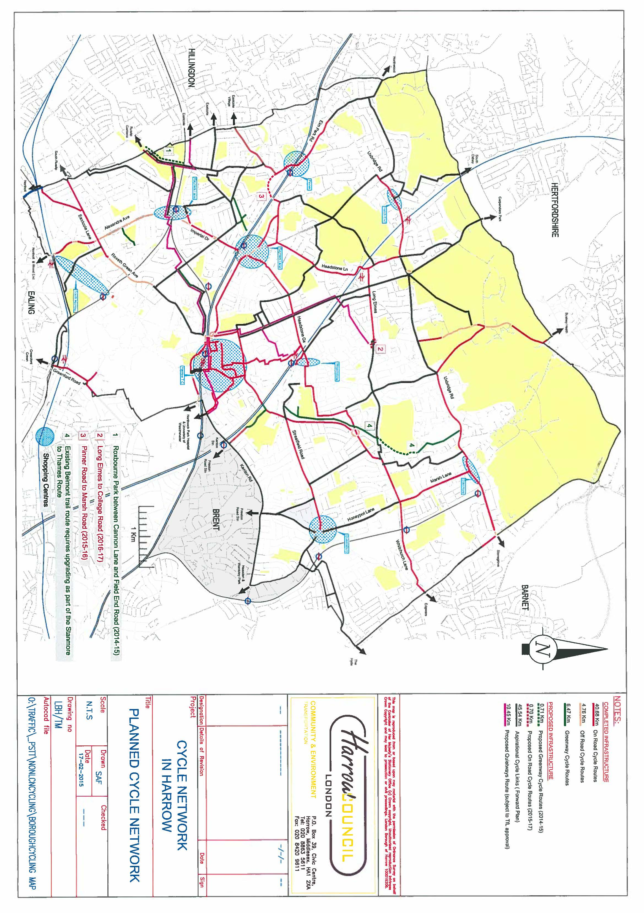
APPENDIX D Cycling Policies in the Harrow Sustainable Transport Strategy

C1 Provide cycle training for adults and children and encourage the use of bicycles generally and in particular for journeys to school

C2 The council will promote the recreational use of cycling – but give priority to its aim of increasing cycling as an alternative to car use.

C3 Ensure cycle routes and facilities in the borough are appropriately located and regularly cleaned and maintained and that whenever possible, cycle tracks in parks are available at all hours

C4 Encourage the use of bicycles generally and in particular for journeys to school.

C5 Encourage employers to make provision for employees wishing to cycle to a similar standard to that required from new development including the provision of “cycle pools”

C6 Publish and distribute cycling leaflets and maps in areas of the borough identifying the locations of designated cycle routes, cycle parking facilities, barriers to use and main road crossings

C7 The council will use its powers as local planning authority to make planning permission for future development conditional upon the availability of an appropriate level of pedal cycle parking and facilities such as showers and lockers and encourage provision of “cycle pools”

C8 The council will use its powers and resources to provide secure and weather-protected cycle parking at sites generating/attracting significant numbers of cycling trips – most particularly, at strategic interchanges and stations and at local shopping areas; and encourage other authorities with specific responsibilities within the Borough to do the same

C9 Work with TfL to support the Mayor’s Cycle Superhighways schemes regarding improving access to the existing schemes or on the basis of bike hire space availability and work towards becoming a biking borough

C10 The council will ensure the progressive achievement and maintenance of a high quality of cycle route provision, as well as clear continuity and consistency in design; and will ensure that, wherever practicable, provision is designed and implemented to cater for tricycle and trailer use
C11 Provide effective alternatives to the car to encourage modal shift and increase provision for non-motorised modes of travel including cycling on all local access roads and treating walking as a priority travel mode, to be treated on a par with other means of transport

C12 Liaise with Railtrack4 and Transport for London to address the lack of cycle parking on station and particularly at Harrow and Wealdstone and Harrow on the Hill stations.

APPENDIX E Linking Borough Cycling Targets to Cycling Policy
Policy Ref | Policy | Targets
P1: Create a safer and better environment that supports cycling as an equal mode of transport
P1.1 | The Council will ensure the progressive development and maintenance of a high quality cycle route provision, clear continuity and consistency in design; and will ensure that, wherever practicable, provision is designed and implemented to also cater for tricycle and trailer use (modified policy C10) | Target 1  Reduce the year on year nos. of KSI incidents involving cyclists as a % of cycling activity recorded in the Borough  Target 2  Reduce the year on year nos. of cyclists with slight injuries as a % of cycling activity recorded in the Borough
P1.2 | The Council will alleviating barriers to cycling by improving the bikeability of all routes in Harrow and ensure that routes are made suitable for entry level cyclists
P1.3 | The Council will ensure cycle routes and facilities in the borough are appropriately located and regularly cleaned and maintained and that whenever possible, cycle tracks in parks are available for use at all hours (modified policy C3)
P1.4 | The Council will work with TfL and other agencies to support the introduction of cycling schemes and initiatives and work towards becoming a biking borough (modified policy C9)
P1.5 | The Council will introduce cycle infrastructure design standards across the Borough
P1.6 | The Council is committed to reducing the risk of collisions involving cyclist through good design, continuous monitoring of collision hotspots and working in partnership with enforcement and community groups.
P1.7 | The Council will work in partnership with adjacent authorities to develop and to maintain high quality and safe cross-boundary cycling infrastructure

Policy Ref | Policy | Targets
P2: Promote cycling as a convenient, safe, secure, inclusive and enjoyable activity
P2.1 | The Council will provide cycle training for adults and children and for people with disabilities to create a confident and responsible cycling community in the Borough (policy C1) | Target 3  Deliver a minimum of 200 adult cycle training courses annually  Target 4  Deliver cycle training courses to a minimum of 30 schools annually  Target 5  Support the delivery of at least 10 led rides in the Borough annually  Target 6  Introduce at least one Bikeability Plus initiative annually  Target 7  Deliver 2 Try Cycling Roadshows annually  Target 8  Support local events by delivering DR Bikes annually
P2.2 | The Council will introduce measures and programmes to encourage persons from BAME and other cycling adverse groups to take up cycling and to cycle more often.
P2.3 | The Council will promote the recreational use of cycling while giving priority to its aim of increasing cycling as an alternative to private car use (policy C2)
P2.4 | The Council will encourage the use of bicycles generally and in particular for journeys to school (policy C4)
P2.5 | The Council will encourage employers to make provision for employees wishing to cycle to a similar standard to that required from new development including the provision of “cycle pools” (policy C5)
P2.6 | The Council will publish and make available cycling leaflets and maps in areas of the borough identifying the locations of designated cycle routes, cycle parking facilities, barriers to cycling and main road crossings (modified policy C6)

Policy Ref | Policy | Targets
P3: To elevate cycling as an important sustainable mode of travel in the Borough
P3.1 | The Council will ensure cycling is at the heart of our sustainable and inclusive policies as a “biking borough” for all | Target 9  Achieve 1.5% mode share for cycling by 2017  Target 10  Increase the number of pupils cycling to school by 1.8% by 2020  Target 11  Undertake an annual resident survey to measure changing attitudes towards cycling
P3.2 | The Council will treat cycling and the needs of cyclists as equally important with other means of sustainable transport in the Borough.
P3.3 | The Council will consider the needs of cyclists as a core element in future regeneration programmes for local centres and employment areas.
P3.4 | The Council will support the development of cycling forums and cycle community groups

Policy Ref | Policy | Targets
P4: To facilitate and to support bicycle ownership/access and secure parking
P4.1 | The Council will use its powers and resources as local planning authority to make planning permission for future development conditional upon the availability of an appropriate level of cycle parking and facilities such as showers and lockers and encourage provision of “cycle pools” (policy C7) | Target 12  Increase the number of cycle parking spaces in schools to 66 pupils per cycle parking space by 2020  Target 13  Reduce the number of cycle thefts in the Borough by 20% annually  Target 14  Deliver an increase in the nos. of on street parking stands annually
P4.2 | The Council will use its powers and resources provide secure and weather-protected cycle parking at sites generating/attracting significant numbers of cycling trips particularly, at strategic interchanges and stations and at local shopping areas; and encourage other authorities with specific responsibilities within the Borough to do the same (policy C8)
P4.3 | The Council will work in partnership with cycling groups, the community and enforcement authorities to reduce cycle theft (Note that working is partnership does not necessarily imply the provision of funding)

APPENDIX F Borough Cycle Action Plan
Operational and Cycle Parking Measures
Action Plan | Cycle Policy Reference
 | 1.1 | 1.2 | 1.3 | 1.4 | 1.5 | 1.6 | 1.7 | 2.1 | 2.2 | 2.3 | 2.4 | 2.5 | 2.6 | 3.1 | 3.2 | 3.3 | 3.4 | 4.1 | 4.2 | 4.3
Deliver free cycle training to children studying or residing in the borough
Produce and update Bikeability travel maps including those produced specifically for schools
Rolling out cycling promotions including campaigns targeted at BME and under-represented groups.
Free cycle training for adults who live, work or study in the Borough including special needs cycle training
Supporting Bike Clubs in high schools
Deliver Learn to Balance and Ride sessions to support supplementary Bikeability training for children aged 3-11
Encourage cycling potential of Women through the introduction of the Women’s Bike Club and Women’s Commuter Club
Deliver tailored Bike Clubs in Special Education Needs (SEN) schools
Try Cycling events
Working with businesses to promote cycling, cycling champions and cycling provision in their premises
Encouraging closer working with Cycle Groups and the private sector to promote cycling in the Borough
Increasing cycle parking provision at and in close proximity to rail stations
Increasing cycle parking provision at and in close proximity to Harrow & Wealdstone station
Increasing cycle parking provision at and in close proximity to Harrow-on-the-Hill station.
Increasing cycle parking provision at and in close proximity Rayners Lane station
Increasing cycle parking provision in schools and colleges
Working with the Met Police, PCSO’s and community groups to promote bike marking & registration service
Introduce cycle infrastructure standards as part of the Council’s design standards

Infrastructure Improvement Measures
Action Plan | Cycle Policy Reference
 | 1.1 | 1.2 | 1.3 | 1.4 | 1.5 | 1.6 | 1.7 | 2.1 | 2.2 | 2.3 | 2.4 | 2.5 | 2.6 | 3.1 | 3.2 | 3.3 | 3.4 | 4.1 | 4.2 | 4.3
Whittington Way to Northumberland Rd cycle improvements (2014-15)
Pinner Rd/Marsh Rd route cycle improvements (2015-2016)
Long Elmes to College Ave junc improvement /cycle link cycle improvements (2016–17)
Roxbourne to Cannons Lane greenway improvements (2014–15)
Canons Lane to Castleton Road greenway improvements Apr (2015–16)
Castleton Road to Field End Road greenway improvements Apr (2016–17)
Stanmore –Thames cycle and walking route Major Scheme (2013–14)
Cloistors Wood traffic management (streets near Stanmore Stn) (2016–17)
Neptune Point traffic management (Pinner Road / Greenhill Way area) (2015-16)
Kodak Site traffic management- (Harrow View / Headstone Drive) (2016–17)
Sudbury Public Realm Improvement
SUSTRANS West London greenway route (Stanmore to Thames Greenway) ⁽¹⁾
Northwick park Roundabout Improvements
Bessborough Roundabouts
TfL Preferred Quietway Route (10.4km) ⁽²⁾
Proposed Jubilee Cycle Route (6km) ⁽³⁾
Proposed Bakerloo Route (6 km) ⁽³⁾
Proposed Metropolitan Cycle Route (5.5km) ⁽³⁾
Proposed Cross Harrow Route (12km) ⁽³⁾
Note:
(1) Stanmore to Thames Greenway funding has yet to be confirmed by TfL
(2) Preferred Quiteway Route that TfL have expressed interest to fund
(3) Quietway Routes that have been proposed by Harrow Council
APPENDIX G Borough Cycle Implementation Plan
Committed Funding

Action Plan | Funding Source (1) | Schedule for Implementation
 |  | 2014/ 15 | 2015/ 16 | 2016/ 17 | 2017/ 20 | Post- 2020
Rolling out Bikeability training | LIP
Produce and update Bikeability travel maps including those produced specifically for schools | LIP
Junior Bike Week for pre-schoolers | LIP
Rolling out cycling promotional including campaigns targeted at BME and under-represented groups. | LIP
Free cycle training for residents in the Borough including special needs cycle training | LIP
Supporting Bike Clubs in high schools | LIP
Try Cycling events | LIP
Working with businesses to promote cycling, cycling champions and cycling provision in their premises | LIP
Encouraging closer working with Cycle Groups and the private sector to promote cycling in the Borough | LIP/ third party
Rolling out Dr Bike events and bike maintenance skills training | LIP
Increasing cycle parking provision at and in close proximity to rail stations | LIP/ Station Improvement
Increasing cycle parking provision at and in close proximity to Harrow & Wealdstone station | LIP/ Station Improvement
Increasing cycle parking provision at and in close proximity to Harrow-on-the-Hill station. | LIP/ Station Improvement
Increasing cycle parking provision at and in close proximity Rayners Lane station | LIP/ Station Improvement
Increasing cycle parking provision in schools and colleges | LIP
Working with the Met Police, PCSO’s and community groups to promote bike marking & registration service | LIP
Introduce cycle infrastructure standards as part of the Council’s design standards | LIP
Whittington Way to Northumberland Rd cycle improvements (2014-15) | LIP
Pinner Rd/Marsh Rd route cycle improvements (2015-2016) | LIP
Long Elmes to College Ave junc improvement /cycle link cycle improvements (2016–17) | LIP
Roxbourne to Cannons Lane greenway improvements (2014–15) | LIP
Canons Lane to Castleton Road greenway improvements Apr (2015–16) | LIP
Castleton Road to Field End Road greenway improvements Apr (2016–17) | LIP
Stanmore –Thames cycle and walking route Major Scheme (2013–14) | LIP
Cloistors Wood traffic management (streets near Stanmore Stn) (2016–17) | LIP
Neptune Point traffic management (Pinner Road / Greenhill Way area) (2015-16) | LIP
Kodak Site traffic management- (Harrow View / Headstone Drive) (2016–17) | LIP
Sudbury Public Realm Improvement | LIP
SUSTRANS West London greenway route (Stanmore to Thames Greenway) ⁽¹⁾ | LIP
Northwick park Roundabout Improvements | Quietways
Bessborough Roundabouts | Quietways
TfL Preferred Quietway Route (10.4km) ⁽²⁾ | Quietways
Proposed Jubilee Cycle Route (6km) ⁽³⁾ | Quietways
Proposed Bakerloo Route (6 km) ⁽³⁾ | Quietways
Proposed Metropolitan Cycle Route (5.5km) ⁽³⁾ | Quietways
Proposed Cross Harrow Route (12km) ⁽³⁾ | Quietways
Note:
(1) Stanmore to Thames Greenway funding has yet to be confirmed by TfL
(2) Preferred Quiteway Route that TfL have expressed interest to fund
(3) Quietway Routes that have been proposed by Harrow Council
APPENDIX H Borough Cycling Monitoring Action

Cycling Target | Monitoring Action/ Data Source
Target 1  Reduce the year on year nos. of KSI incidents involving cyclists as a % of cycling activity recorded in the Borough | Casualty Statistics from Met Police/ TfL
Target 2  Reduce the year on year nos. of KSI incidents involving cyclists as a % of cycling activity recorded in the Borough | Casualty Statistics from Met Police/ TfL
Target 3  Deliver a minimum of 200 adult cycle training courses annually | Harrow Council data
Target 4  Deliver cycle training courses to a minimum of 30 schools annually | Harrow Council data
Target 5  Support the delivery of at least 10 led rides in the Borough annually | Harrow Council/ Harrow Cyclists
Target 6  Introduce at least one Bikeability Plus initiative annually | Harrow Council
Target 7  Deliver 2 Try Cycling Roadshows annually | Harrow Council/ Harrow Cyclist
Target 8  Support local events and schools by delivering DR Bikes annually | Harrow Council

Target 9  Achieve 1.5% mode share for cycling by 2017 | Harrow Council manual count data at strategic sites in the Borough  Cycle count data from TfL and other sources  Harrow Council data from other surveys being carried out by the Council  Data from the iTRACE system to monitor school and site travel plans  Counts of parked bicycles at key locations
Target 10  Increase the number of pupils cycling to school by 1.8% by 2020 | Data from the iTRACE system to monitor school and site travel plans  School Hands Up survey data  Manual counts at school sites
Target 11  Undertake an annual resident survey to measure changing attitudes towards cycling | Harrow Council data on frequency of cycling, cycle ownership and cycle as part of other surveys being carried out by the Council  Feedback on the effectiveness of cycling activities such as led rides and Skyride
Target 12  Increase the number of cycle parking spaces in schools to 66 pupils per cycle parking space by 2020 | Harrow Council
Target 13  Reduce the number of cycle thefts in the Borough by 20% annually | Metropolitan police data on cycle theft
Target 14  Deliver an increase in the nos. of on street parking stands annually | Harrow Council

